Weekly Report Out 7

Team: Drone Link

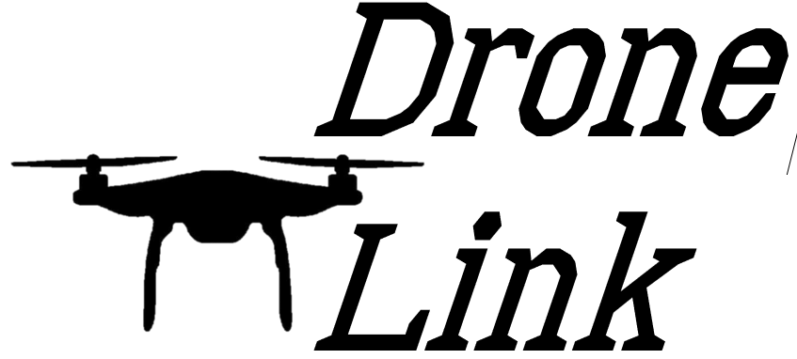Sam Forest, Alex Holt, Vincent Krenz, Lucas Larocco, Blake Masbruch

10/30/2020

Senior Design Adviser: Professor Wiedenhoeft

ScrumMaster: Vincent Krenz

Current Cadence: 3

**Progress**

We have completed the current process improvements of streamlining documentation; this should free up Vincent some for development work. This included the creation of a docs folder that will continue to be populated as we go. Blake has been training everyone on front end work as he has the most experience with react, this has gone slower than expected because everyone has very full schedules. Blake’s one on one communication has been invaluable for speeding up our front-end development and our future work. Overall, we are completing development at a good pace.

**Future Progress**

Our goal is to complete the tickets currently in the backlog and have been making good incremental progress towards that goal. We also made the deadline for the completion of our final presentation to be November 9th, this gives us 2 days to prepare and fine tune the presentation to make it flow smoothly and be an accurate representation of our great work.

**Reflection**

Development work has been moving more smoothly as we all attempt to overcome senioritis and recover from midterms. We have tickets assigned to everyone and are working towards getting development norms stated. This includes the creation of a definition of done that is evolving around our progress in this cadence, and future cadences.